Ecommerce Customer_Vendor Behavior Analysis Report
Objectives:
- Analyze customer churn rate and its regional distribution.
- Evaluate vendor performance based on sales and ratings.
- Track monthly revenue trends across regions.
- Measure delivery success rate and repeat purchase patterns.
- Generate actionable business recommendations from data insights.
Tools and Technologies Used:
Tool | Purpose
Python (Pandas, NumPy) | Data Cleaning, Transformation, and Exploratory Data Analysis (EDA)
SQL Server | Data Modeling, Relationship Setup, and Analytical Querying
Power BI | Dashboard Visualization and KPI Reporting
DAX (Data Analysis Expressions) | Custom Measures and Calculations
GitHub | Version Control and Project Documentation

Dataset Details:
The dataset consists of three main tables:
Table Name | Description | No. of Columns
customers | Contains customer demographics, region, churn status, and join date | 8
orders | Includes order details such as amount, payment method, and delivery status | 8
vendors | Vendor-wise information on ratings, total products, and onboarding date | 6

Data Preparation (Python):
🔸 Key Steps:
Removed duplicates and handled missing values.
Corrected inconsistent region names (e.g., "south americ" → "south america").
Standardized date formats and data types.
Created additional features such as customer_age_group, order_month, and vendor_performance_score.
🔸 Example Code Snippet:
# Clean region names
df_customers['region'] = df_customers['region'].str.strip().str.lower().replace({'south americ':'south america'})
# Convert dates
df_orders['order_date'] = pd.to_datetime(df_orders['order_date'])

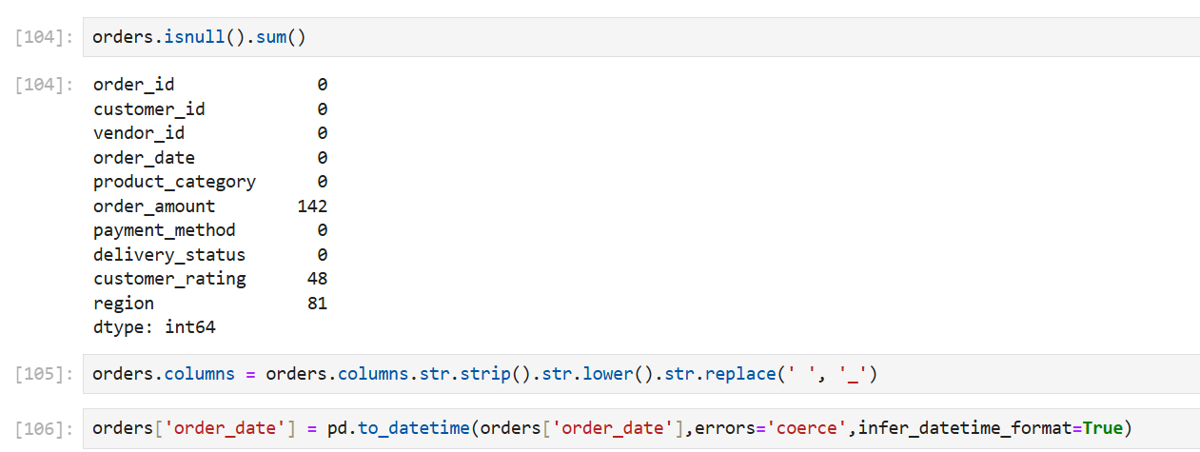

SQL Data Analysis:
After exporting cleaned tables to SQL Server, we executed several analytical queries.
🔹 Key Business Queries:
1)Which regions have the highest customer churn rates?
2)Which customers haven’t placed an order in the past 90 days?
3)What percentage of customers made more than one purchase?
4)Which regions generate the highest average order value?
5)Which vendors generate the highest revenue and maintain high customer ratings?
6)Which product categories have the highest return/cancellation rate?
7)What is the average total revenue per customer?(CLV)
8)What percentage of total revenue does each vendor contribute?
9)What is the monthly revenue, total orders, and average order value trend over time?
10)Which regions and product categories generate the highest revenue and how do they contribute to overall sales performance?

Example SQL Query:
select region,
count(customer_id) as total_customers,
sum(case when churn_status = 'churned' then 1 else 0 end) as churned_customers,
round(sum(case when churn_status = 'churned' then 1 else 0 end)*100.0/count(customer_id),2) as churn_rate_pct
from customers
group by region
order by churn_rate_pct desc;
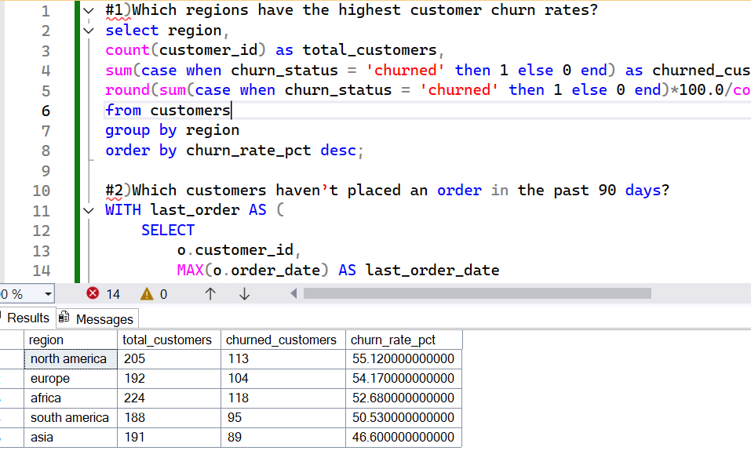

Power BI Dashboard:
Dashboard Name: E-Commerce Vendor Performance & Customer Churn Analysis
🔸 Key Visuals:
Visual | Description
KPI Cards | Total Orders, Total Revenue, Churn %, Repeat Purchase %, Delivery Success %
Bar Chart | Customer Churn % by Region
Donut Chart | Active vs Churned Customers
Area Chart | Monthly Revenue Trend by Region
Bubble Chart | Bottom 5 Vendors by Rating and Revenue
Slicers | Filters for Region, Product Category, Weekday, and Year

Insights & Findings:
High churn in North America (55%) and Europe (54%) → indicates dissatisfaction or delivery issues.
Delivery success rate is low (33.1%) → potential operational bottleneck.
Repeat purchase rate is strong (80.7%) → loyal customer base exists.
Revenue peaks between March–July → promotional campaigns likely effective.
Asia and South America show stable growth with lower churn → high market potential.
Vendor performance varies widely → quality inconsistency impacts brand image.

Recommendations:
Improve delivery efficiency by partnering with reliable logistics providers.
Launch targeted retention campaigns for high-churn regions.
Introduce vendor quality rating incentives.
Use predictive churn models in Python to identify at-risk customers.
Enhance marketing around seasonal high-performing months.
Expand focus on Asia and South America, where engagement is rising.
